[PLACE CHURCH LOGO HERE]
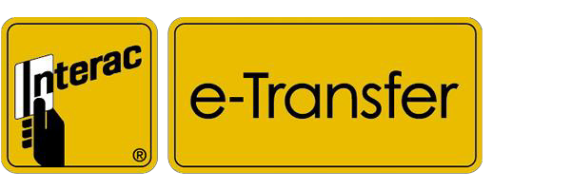

ONLINE GIVING with Interac e-TRANSFER

Interac e-Transfer is a simple, convenient, and secure way to send and receive money directly from one bank account to another. All you need is access to online or mobile banking through a participating financial institution, and you can send money to anyone with an email address or mobile phone number and a bank account in Canada — without sharing any personal or financial information. It's a great alternative to cheques and cash.
How to donate to [YOUR CHURCH NAME] using Interac e-TRANSFER:
- Login to online or mobile banking at your participating financial institution
- Choose Interac e-Transfer within the Transfer/Payment menu options
- Set up your sender profile and add [YOUR CHURCH NAME] – make sure to create a Security Question and inform the church secretary of the answer by separate email to [CHURCH ETRANSFER EMAIL ie giving@yourchurchname.ca] or by phone.
- Using the email account, [ie giving@yourchurchname.ca] enter the amount you wish to send and which account the funds will be transferred from. You have the option to designate your funds in the memo field if applicable.
- Send! The funds are debited from your account immediately.
- Once the funds have been processed by the church, you will receive a confirmation email of your donation. If you have any questions please contact [NAME OF Church Office Contact] at the church office: [OFFICE EMAIL] or [CHURCH PHONE #].
- At year end, you will be issued a Canadian Tax Receipt for your donations to the church.

